|  |  |  |  |  |  |  |
| --- | --- | --- | --- | --- | --- | --- |
| * **Model: GLT4000-7VMK**   **Powered by KUBOTA D1105-BG** | | | | | | |
|  | |  |  | | |  |
| * **Generator Specification** | |
| **Service** | **PRP(1)** | **ESP(2)** |  | **Performance Data** |  |  |
| Genset power (KW) | 6.7 | 7.3 |  | Model | GLT4000-7VMK | |
| Voltage | 110~240 |  |  | Engine brand |  | **KUBOTA** |
| Frequency | 50/60Hz |  |  | Engine model |  | D1105-BG |
| Engine speed | 1500/1800R.P.M |  |  | Speed control type |  | Mechanical |
| Power factor | 1.0 |  |  | Alternator brand | **STAMFORD | GENLITEC** | |
| Phase | Single |  |  | Alternator model | PI 044E | S164G8 | |
|  |  |  |  | Control system | SMARTGEN HGM1790N | |
| timg.jpg  GENLITEC Power lighting towers & generator sets are compliant with ISO 9001 and CE standard, which include the following directives:   * 2006/42/EC Machinery safety. * 2006/95/EC Low voltage * EN 60204-1: 2006+A1: 2009, EN ISO 12100: 2010, EN ISO 13849-   1:2008, EN 12601: 2010   1. **PRP (Prime Power)**   According to ISO 8528-1, prime power is the maximum power available during a variable power sequence, which may be run for an unlimited number of hours per year, between stated maintenance intervals. The permissible average power output during at 24 hours period shall not exceed 80% of the prime power. 10% overload available for governing purposes only.   1. **ESP (Standby Power)**   According to ISO 8528-1. It is defined as the maximum power available, under the agreed operating conditions, for which the generating set is capable of delivering for up to 500 hours of operation per year (of which no more than 300 hours for continuative use) with the maintenance intervals and procedures being carried out as prescribed by the manufactures. No overload capability is  available. | | | Starter motor voltage | | | 12V |
|  | Max. height of mast |  | 7 meters |
| Mast lifting/lowing system | | | Mechanical |
| Total power of lamps | | | 4x1000 watts |
| Fuel consumption (Full Load) | | | 2.0L/H |
|  | Fuel tank capacity |  | 80~100L |
|  | **Standard Reference Conditions** |  |  |
| Note: Standard reference condition 25℃ (77°F) air inlet temp. 100m (328ft) A.S.L 30% relative humidity. Fuel consumption date with diesel fuel with specific gravity of 0.85 and conforming to BS 2869: 1998 Class A2 | | | |
|  | **Dimension & Weight** |  |  |
| LOADING1.jpg | | | |
|  | **Dimension** | **Storage** | **Working** |
|  |  |  |  | Length (L) | 4250mm | 2600mm |
| **Container Loading Cap** | **acity** |  |  | Width (W) | 1450mm | 2350mm |
|  | CONTAINER LOADING.png | |  | Height (H) | 2150mm | 7000mm |
| **6 SETS / 20GP** |  | Net Weight | 870kg | |
|  | **Note: This parameters allows for some acceptable deviations.** | | | |
| **12SETS / 40HQ** |  | | | |

无标题111111111.jpg

|  |  |  |  |  |
| --- | --- | --- | --- | --- |
| * **Engine Specification** |  |  | * **Alternator Specificat** | **tion** |
| D1703-D1803-450.png |  | b_49UL5W2A.png | | |
| **MODEL: KUBOTA D1105-BG** |  |  | **MODEL: STAMFORD PI 044E |** | **GENLITEC S164G8** |
| Cylinder number | 3 |  | Number of phase | Single |
| Aspiration system | Natural |  | Rated power (KW) | 8 |
| Cooling method | Water cooled |  | Frequency (Hz) | 50/60 |
| Combustion system | E-TVCS |  | Power factor (Cos Phi) | 1 |
| Bore x Stroke (mm) | 78.0x78.4 |  | Temp. rise | 125K |
| Compression ratio | 22:1 |  | Insulation type | H class |
| Rated speed (RPM) | 1500 |  | Ambient temp. | 40℃ |
| Displacement (L) | 1.123 |  | IP rating | IP23 |
| Rated power (KW) | 8.4 |  | Excitation system | Self-excited |
| Standby power (KW) | 9.5 |  | Bearing | Single bearing |
| Fuel injection pump | Bosch type PFR MD pump |  | Coating | Vacuum impregnation |
| Injection | Throttle type |  | Voltage regulator | A.V.R |
| Oil capacity (L) | 5.1 |  | Coupling | Flexible disc |
| Charger Alternator capacity | 12V – 30A |  |  |  |
| Starter motor capacity | DC 12V – 1.0A |  |  |  |

|  |  |  |  |  |
| --- | --- | --- | --- | --- |
| * **Operation Mast Specification** |  |  | * **Lamps Specification** |  |
| Max. height of mast | 7m |  | Total power of lamps | 4 x 1000 watts |
| Elevation system | Mechanical |  | Lamps type | Metal halide lamps |
| Raising/Lowing mast method | Manual winch |  | Light capacity | 4 x 110,000 lumen |
| Mast stages | 6 |  | Design lifetime | 5000 hours |
| Turning angle | 358° manually |  | Working temperature | ≤85℃ |
| Mast material | Steel tube |  | Light coverage | 5 ~ 7 acres |

|  |  |  |  |  |
| --- | --- | --- | --- | --- |
| * **Chassis Specification** |  | * **Controller Panel Specification** | | |
| Hitch type | Ring/Ball tow hitch |  | Control module | SMARTGEN HGM1790N |
| Brake type | Mechanical hand brake |  | Main & Lamps Breaker | DELIXI |
| Trailer structure | Single axle |  | Emergency stop | Equipped |
| Tyre size | 13 inch |  | Starting method | Electric (Key start) |
| Leveling jack type | Manual |  | Output Socket | 1 x Single phase |

无标题111111111.jpg

* 无标题111111111.jpg**Lighting Area**

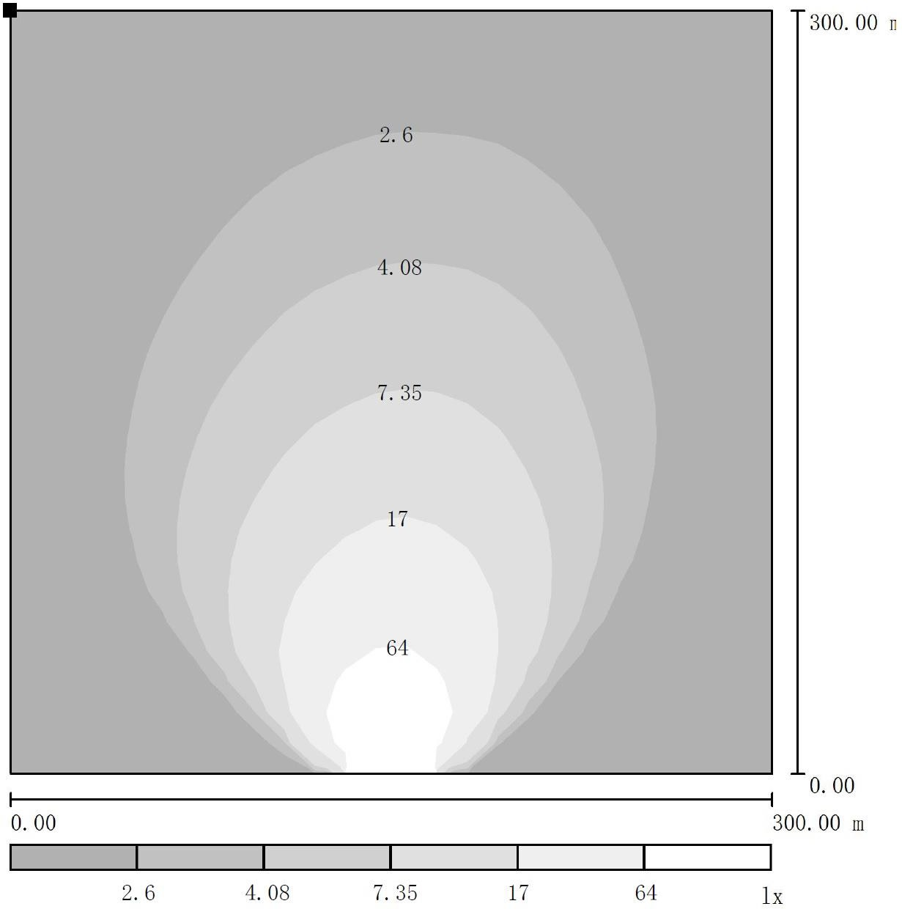

* **Standard Supply Scope**
  + Industrial exhaust silencer  Flexible pipes  Float Battery charger  Base frame
  + Maintenance free battery  Battery wires  Manual books  Digital control panel
  + Water cooling radiator  Wiring diagram  Tool kits  Main circuit breaker
  + A.V.R  Build-in based fuel tank  Emergency stop button  Power output socket x 1
  + Weather proof canopy  Top caution light  Ball/Ring hitch with save chain
* **Optional Supply Scope**

|  |  |  |  |
| --- | --- | --- | --- |
| **Engine** | **Alternator** | **Control Panel** | **Lamps** |
| * **YANMAR** 3TNV76 engine | * **STAMFORD** alternator | * **Smartgen ALC controller** | * 4x1500W lamps |
| * **KUBOTA** D1105-BG engine | * **MECC ALTE** alternator | Sunrise & sunset start/stop | * Spotlights |
| * Water jacket pre-heater |  | Remote start/stop | * 4x300W LED Spotlights |
| * Battery isolator |  | * ABB breakers * Power output socket x 2 |  |
|  |  |  |

* **Control Panel**

|  |  |  |  |
| --- | --- | --- | --- |
| **Configuration** | productmvwl6s28rg.jpg | | |
| * Emergency stop button |
| * Protection MCB + Lamps & Socket circuit breaker |
| * Digital control module |
| * Power output socket x 1 (Single Phase) |
| * Weather proof controller box |
| * Alarm buzzer |
| 捕获.JPG |
| **Key Features** |  | **Control Module:SMARTGEN** | **HGM1790N** |
| * Large back-lit icon LCD display |  | Digital input | 5 |
| * Single / Three phase generator monitoring |  | Relay output | 5 |
| * AC phase voltage display |  | Communication interface | PC |
| * Generator frequency display |  | AMF | M/A |
| * Engine speed RPM display |  | AC System | 1P2W / 2P3W / 3P3W / 3P4W |
| * Battery voltage Vdc display |  | Phase voltage input | 0-300Vac |
| * Generator running hours display |  | Frequency range | 3Hz – 70Hz |
| * Engine coolant temperature display |  | Standby current | TBA |
| * Engine oil pressure display |  | Accuray | 1% |
| * Pre-alarm & shutdown alarm function |  | Control relay outputs | 3A/30Vdc |
| * Low oil pressure shutdown alarm |  | DC supply | DC 8-35V |
| * Engine high temperature shutdown alarm |  | Operating temp. | -20 ~ +70℃ |
| * Engine over speed shutdown alarm |  |  |  |
| * Generator over/under voltage shutdown alarm |  |  |  |
| * Generator over load shutdown alarm |  |  |  |
| * Start/Stop failure shutdown alarm |  |  |  |
| * IP65 rating offers increased resistance to water ingress |  |  |  |

* **Controller Module Options**

|  |  |  |
| --- | --- | --- |
| **SMARTGEN** | **COMAP** | **DEEPSEA** |
| **ALC704** | **Inteli Nano** | **Inteli Nano** |
| products0gl2y6qm3.jpg | InteliNano-new-front_small.png.png | TIM截图20180508162428.png |

.