* **Model: GLT1600L-8HK**

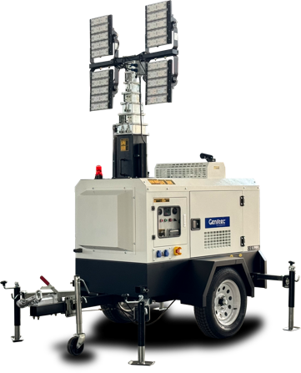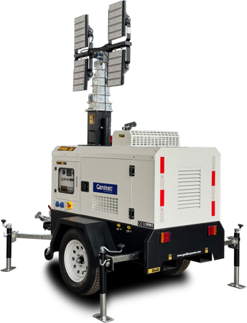**Powered by KUBOTA**

* **Generator Specification**



GENLITEC Power lighting towers & generator sets are compliant with ISO 9001 and CE standard, which include the following directives:

|  |  |  |  |  |
| --- | --- | --- | --- | --- |
| **Service** | **PRP(1) ESP(2)** |  | **Performance Data** |  |
| Genset power (KW) | 6.7 7.3 |  | Model | GLT1600L-8HK |
| Voltage | 220V, 230V, 240V |  | Engine brand | KUBOTA |
| Frequency | 50/60Hz |  | Engine model | D1105-BG |
| Engine speed | 1500/1800R.P.M |  | Speed control type | Mechanical |
| Power factor | 1.0 |  | Alternator brand | GENLITEC |
| Phase | Single |  | Alternator model | S164G8 |
|  |  |  | Control system | SMARTGEN HGM1790N |
|  |  |  | Starter motor voltage | 12V |
|  |  |  | Max. height of mast | 8.5 meters |

* 2006/42/EC Machinery safety.
* 2006/95/EC Low voltage
* EN 60204-1: 2006+A1: 2009, EN ISO 12100: 2010, EN ISO 13849-

1:2008, EN 12601: 2010

### PRP (Prime Power)

According to ISO 8528-1, prime power is the maximum power available during a variable power sequence, which may be run for an unlimited number of hours per year, between stated maintenance intervals. The permissible average power output during at 24 hours period shall not exceed 80% of the prime power. 10% overload available for governing purposes only.

### ESP (Standby Power)

According to ISO 8528-1. It is defined as the maximum power available, under the agreed operating conditions, for which the generating set is capable of delivering for up to 500 hours of operation per year (of which no more than 300 hours for continuative use) with the maintenance intervals and procedures being carried out as prescribed by the manufactures. No overload capability is available.

**Container Loading Capacity**

# 4 SETS / 20GP

## 8 SETS / 40HQ

Mast lifting/lowing system Mechanical Total power of lamps 4x400 watts **LED**

Fuel consumption ***(100% load)*** 2.0L/H Fuel tank capacity 115L

**Standard Reference Conditions**

Note: Standard reference condition 25℃ (77°F) air inlet temp. 100m (328ft) A.S.L 30% relative humidity. Fuel consumption date with diesel fuel with specific gravity of 0.85 and conforming to BS 2869: 1998 Class A2

**Dimension & Weight**

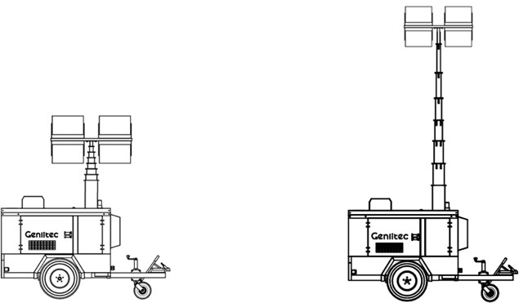

|  |  |  |  |
| --- | --- | --- | --- |
| **Dimension** | **Storage** |  | **Working** |
| Length (L) | 2810mm |  | 2810mm |
| Width (W) | 1440mm |  | 2450mm |
| Height (H) | 2890mm |  | 8500mm |
| Net Weight |  | 950kg |  |

**Note: This parameters allows for some acceptable deviations.**

* **Engine Specification** ■ **Alternator Specification**

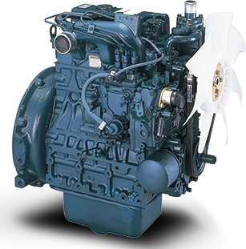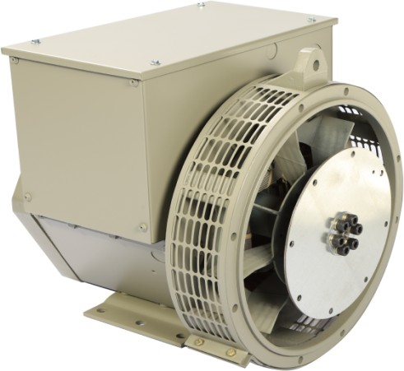

|  |  |  |  |  |
| --- | --- | --- | --- | --- |
| **MODEL: KUBOTA D1105-BG** |  |  | **MODEL: GENLITEC S164G8** |  |
| Cylinder number | 3 |  | Number of phase | Single |
| Aspiration system | Natural |  | Rated power (KW) | 8 |
| Cooling method | Water cooled |  | Frequency (Hz) | 50/60 |
| Combustion system | E-TVCS |  | Power factor (Cos Phi) | 1 |
| Bore x Stroke (mm) | 78.0x78.4 |  | Temp. rise | 125K |
| Compression ratio | 22:1 |  | Insulation type | H class |
| Rated speed (RPM) | 1500/1800 |  | Ambient temp. | 40℃ |
| Displacement (L) | 1.123 |  | IP rating | IP23 |
| Rated power (KW) | 8.4 |  | Excitation system | Self-excited |
| Standby power (KW) | 9.5 |  | Bearing | Single bearing |
| Fuel injection pump | Bosch type PFR MD pump |  | Coating | Vacuum impregnation |
| Injection Nozzle | Throttle type |  | Voltage regulator | A.V.R |
| Oil capacity (L) | 5.1 |  | Coupling | Flexible disc |
| Charger Alternator capacity | 12V – 30A |  |  |  |
| Starter motor capacity | DC 12V – 1.0A |  |  |  |

* **Operation Mast Specification** ■ **Lamps Specification**

|  |  |  |  |  |
| --- | --- | --- | --- | --- |
| Max. height of mast | 8.5m |  | Total power of lamps | 4 x 400 watts |
| Elevation system | Hydraulic |  | Lamps type | LED |
| Raising/Lowing mast method | Electric Button |  | Light capacity | 4 x 60,000 lumen |
| Mast stages | 8 |  | Design lifetime | 50000 hours |
| Mast Turning angle | 358° |  | Working temperature | -25℃ ~ 50℃ |
| Lights Turing angle | - |  | Light coverage | 4000 ㎡ |
| Mast material | Galvanization Steel tube |  | Protection grade | IP67 |

* **Chassis Specification** ■ **Controller Panel Specification**

|  |  |  |  |  |
| --- | --- | --- | --- | --- |
| Tow Hitch type | “O” ring or Ball tow hitch |  | Control module | SMARTGEN HGM1790N |
| Brake type | Mechanical hand brake |  | Main & Lamps Breaker | DELIXI |
| Trailer structure | Single axle |  | Emergency stop | Equipped |
| Tyre size | 14 inch |  | Starting method | Electric (Key start/Button)) |
| Leveling jack type | 5 x Manual |  | Output Socket | 1 x Single phase |

**LED Lighting Area**

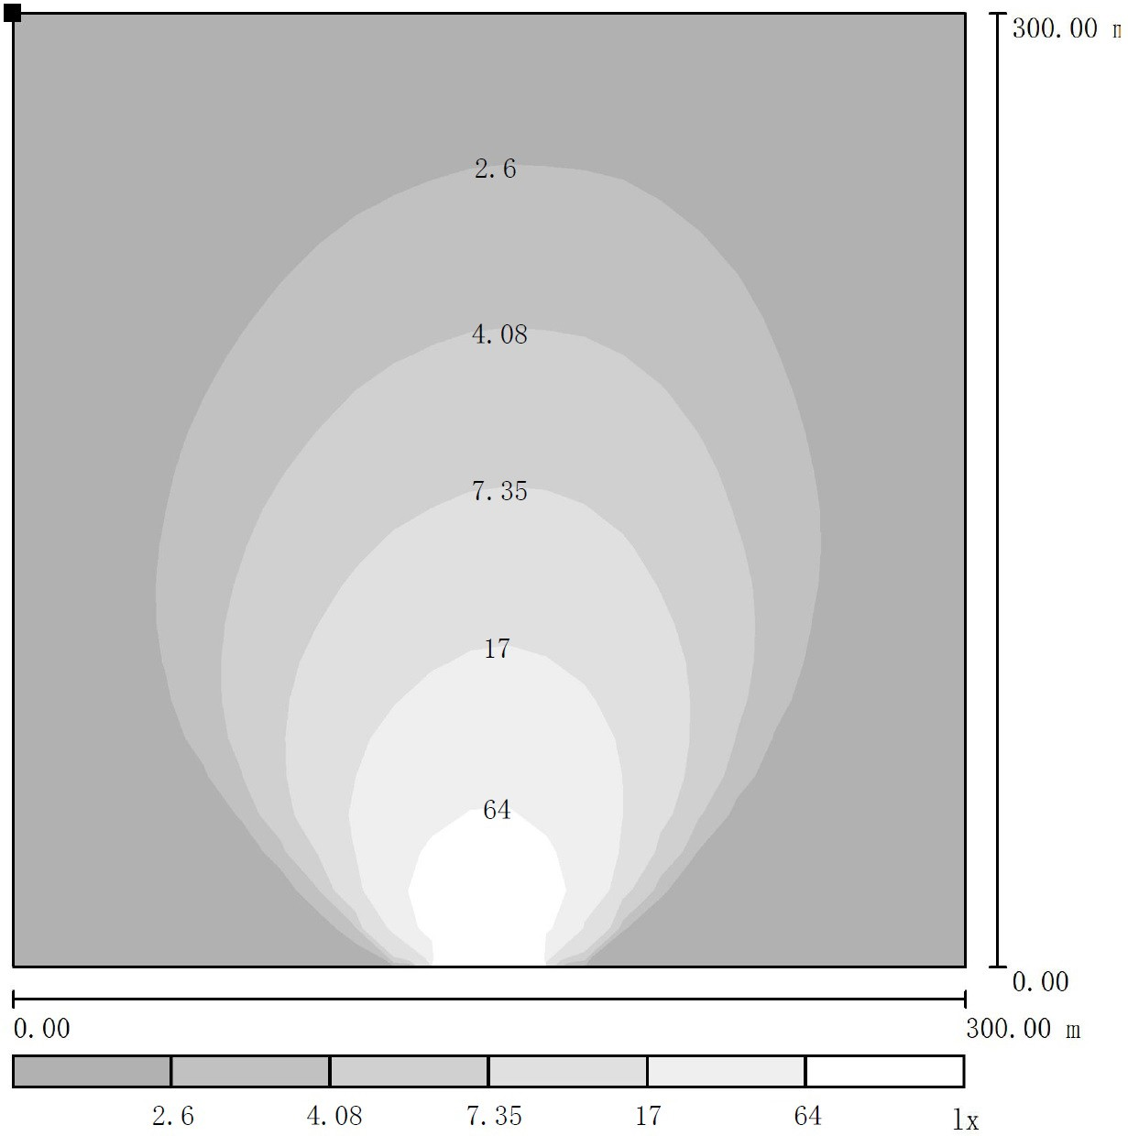

**Standard Supply Scope**

|  |  |  |  |  |  |  |  |
| --- | --- | --- | --- | --- | --- | --- | --- |
|  | Industrial exhaust silencer |  | Flexible pipes |  | Float Battery charger |  | Base frame |
|  | Maintenance free battery |  | Battery wires |  | Manual books |  | Digital control panel |
|  | Water cooling radiator |  | Wiring diagram |  | Tool kits |  | Main circuit breaker |
|  | A.V.R |  | Build-in based fuel tank |  | Emergency stop button |  | Power output socket x 1 |
|  | Weather proof canopy |  | Top caution light |  | Ball/Ring hitch with save chain |  |  |

* **Optional Supply Scope**

|  |  |  |  |
| --- | --- | --- | --- |
| **Engine** | **Alternator** | **Control Panel** | **Lamps** |

|  |  |  |  |  |  |  |  |
| --- | --- | --- | --- | --- | --- | --- | --- |
|  | **PERKINS 403D-11G** engine |  | **STAMFORD** alternator |  | **Smartgen ALC controller** |  | 4x1500W lamps |
|  | **YANMAR 3TNV** engine |  |  |  | **Deepsea DSEL401 MKII** |  | 4x1000W MH Lamps |
|  | **QUANCHAI QC380D** engine |  |  |  | ABB breakers |  |  |
|  | Water jacket pre-heater |  |  |  |  |  |  |
|  | Battery isolator |  |  |  |  |  |  |

* 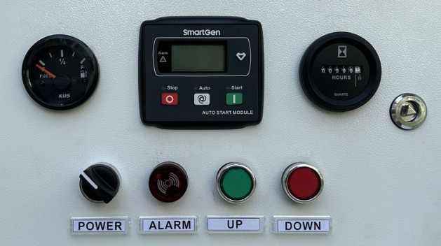**Control Panel**

**Configuration**

Emergency stop button

Protection MCB + Lamps & Socket circuit breaker

Digital control module

Power output socket x 1 (Single Phase)

Weather proof controller box

Alarm buzzer

|  |  |  |  |  |
| --- | --- | --- | --- | --- |
| **Key Features** | |  | **Control Module:SMARTGEN HGM1790N** | |
|  | Large back-lit icon LCD display |  | Digital input | 5 |
|  | Single / Three phase generator monitoring |  | Relay output | 5 |
|  | AC phase voltage display |  | Communication interface | PC |
|  | Generator frequency display |  | AMF | M/A |
|  | Engine speed RPM display |  | AC System | 1P2W / 2P3W / 3P3W / 3P4W |
|  | Battery voltage Vdc display |  | Phase voltage input | 0-300Vac |
|  | Generator running hours display |  | Frequency range | 3Hz – 70Hz |
|  | Engine coolant temperature display |  | Standby current | TBA |
|  | Engine oil pressure display |  | Accuray | 1% |
|  | Pre-alarm & shutdown alarm function |  | Control relay outputs | 3A/30Vdc |
|  | Low oil pressure shutdown alarm |  | DC supply | DC 8-35V |
|  | Engine high temperature shutdown alarm |  | Operating temp. | -20 ~ +70℃ |
|  | Engine over speed shutdown alarm |  |  |  |
|  | Generator over/under voltage shutdown alarm |  |  |  |
|  | Generator over load shutdown alarm |  |  |  |
|  | Start/Stop failure shutdown alarm |  |  |  |
|  | IP65 rating offers increased resistance to water ingress |  |  |  |

* **Controller Module Options**

**SMARTGEN**

**COMAP**

**DEEPSEA**

## ALC404 Inteli Nano DSEL401 MKII

